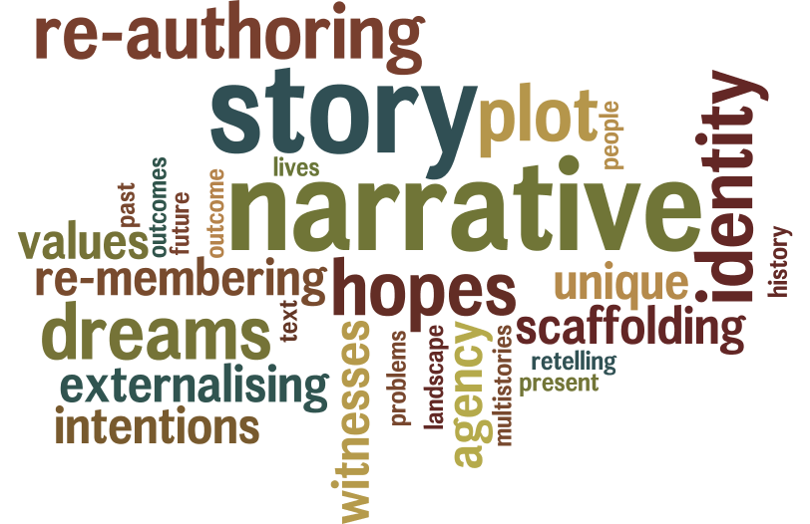

**Narrative Therapy**

**Level 1 Training on line [Zoom] Autumn 2021**

**Monday evenings 7.00-9.30pm**

**August 30th, September 6th, 13th, 20th,27th,**

**October 4th, 11th, 18th, November 1st 8th,**

**Cost 400 euros**

**Thérèse Hegarty**

**Narrative Therapy** was developed by Michael White and David Epston. It is an approach that recognises people as the experts on their own lives.It understands that our lives are shaped by the stories we tell about ourselves, the stories that others tell about us and the way those stories are shaped by our culture and community. Each relationship and context in our lives offers us a new story.

Narrative Therapy, unlike many therapies, is not based in psychology. Theoretically it draws more from philosophy and anthropology including Bateson, Foucault, Bruner, and Myerhoff. It is located in postmodern thinking.

When a person brings a problem to therapy, we explore the influence of the problem on the person and the influence of the person on the problem. We pay attention to the skills, beliefs, commitments and values of the person and their hopes for their lives. Of central concern is the identity of the person and how they can exert agency.

Therapy is often described as “client-centred” Narrative Therapy might be described as “client-in-context-centred”. The therapist is accountable to the goals of therapy as expressed by the client and maintains a respectful and decentred position throughout.

**Level one**

* The metaphor of story: acknowledging stories that dominate identity and listening for alternative stories.
* Externalising conversations: the person is not the problem, the problem is the problem.
* Re-authoring conversations: telling our stories in ways that make us stronger.
* Re-membering conversations: seeing ourselves through the eyes of others.
* Outsider-witness practices: linking lives and the use of audiences.
* The “Tree of Life”: Gathering our preferred stories.
* Ethics of Narrative Practice

The training is not accredited by the Dulwich Centre in Adelaide but will be recognised by them as equivalent to their Level 1 training.

**The core text** is “Maps of Narrative Practice” [Michael White 2007 Norton].

It is helpful to have read this in advance. Participants will commit to reading a chapter each week. They will also be encouraged to try the ideas in their work and complete personal journaling exercises. There will be short lectures, experiential exercises, structured interviews and discussion throughout.

Participants will make a short presentation on what they have learned in the final week focusing on one of the four Maps: Externalising, Re-authoring,

Re-membering or Witnessing.

**Thérèse Hegarty** began her career as a primary teacher and spent 20 years as a teacher in West Tallaght, where she was involved in the development of the Support Teacher project. She then undertook a Masters in Family Therapy at the Mater Hospital [UCD] and manages a community-based Family Therapy service at CARP Killinarden. She travelled to Adelaide in 2007/2008 to study with Michael White and was awarded the International Diploma in Narrative Therapy and Community Work.

___________________________

To register for this course please contact me by email. If you are unsure if this is the right level for you, we can arrange a phone conversation to discuss what is best. Payment will be by credit transfer on or before August 26th 2021.

Thérèse Hegarty [theresehegarty@gmail.com](mailto:theresehegarty@gmail.com)